Modeling a River System

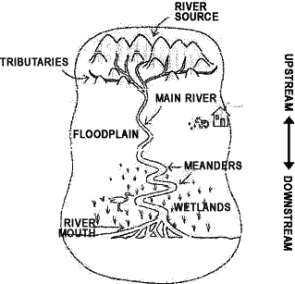

Today you will begin creating a model that illustrates a river system. In your scene you should include (in a reasonable manner) a young river system that details the features found in young river valleys. Your young river system MUST include the following:
- Waterfalls
- V shaped valleys
- Rapid moving water

You are also responsible for illustrating an older, more mature river system.
In this area you should include meanders (at least three), oxbow lakes, natural levees and wide floodplains. At the end of this model you will identify your base level, the mouth of the river and the delta. Name your river and make sure you label (with toothpicks and tape) each feature.

These models will be graded and count as a project grade. Do your best work. Time on task will also be considered part of your grade and will be assessed each day of the project. Keep your work area and equipment clean and orderly.
You will NOT BE PERMITTED to work on this project at home.

The due date for this assignment is: __________________________________

